# Project Design Phase-II Technology Architecture

|  |  |
| --- | --- |
| Team ID | PNT2022TMID27134 |
| Project Name | Smart waste Management System for Metropolitan Cities |
| Team Members | BENTYSON.J,  AINEESH GOLDA.A,  DHILEEPAN.A,  AKASH.T |

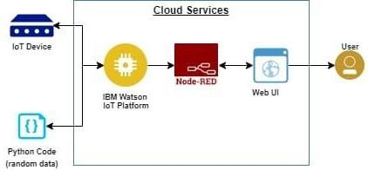**Technical Architecture:**

The Deliverable shall include the architectural diagram as below and the information as the table 1&table 2

**Table-1:Components&Technologies:**

|  |  |  |  |
| --- | --- | --- | --- |
| **S.N0** | **Components** | **Description** | **Technology** |
| 1. | User interface | User interact with application using  form,login,request notification | Python/HTML/MYSQL/JAVA |
| 2. | Registration | User register in the application to connect bank account | Python/HTML/MYSQL/JAVA |
| 3. | Verification | Verification in the application to  connect bank account | Python/HDML/MYSQL/JAVA |
| 4. | Sensor(IOT device) | A device that responds to a physical stimulus (such as heat,light,sound, pressure,magnetism,or a particular motion)and transmit a resulting  impulse. | Raspberry pi/Arduino UNO/Temperature sensor/ultrasonic sensor |
| 5. | Sends notification | Sends the notification to the cloud database | IBM Cloud |
| 6. | Cloud Database (Node Red) | Database service on cloud | Node Red |
| 7. | Application | A computer software package that  performs a specific function directly for an end user | IBM Wastson STT service |

# Table-2:Application Characteristics:

|  |  |  |  |
| --- | --- | --- | --- |
| **S.No** | **Characteristics** | **Description** | **Technology** |
| 1. | Open-Source Framework | Open source is a term denoting that a product includes permission to use its  source code,design documents or content. | Bootsrap |
| 2. | Scalable Architecture | It connected with scalable architecture | IBM Watson |
| 3. | Availability | This application access is availble at the  work time of the workers according to their corporation or municipality. | Python |
| 4. | Performance | Record resource requests and save registered information.  Availability of application. | IBM Watson |